<Give Here Your Own Project Title>
Design Document

Version 1.0



Group Id: S15CS61932BD7

Supervisor Name : Tanweer Arshad

Revision History
Date (dd/mm/yyyy) | Version | Description | Author
20-10-2015 | 1.0 | Introduction of the project | BS000000  BS110000000

Table of Contents

- Introduction of Design Document
- Entity Relationship Diagram (ERD)
- Sequence Diagrams
- Architecture Design Diagram
- Class Diagram
- Database Design
- Interface Design
- Test Cases

- Introduction of Design Document
In this document, we have included ERD, Sequence and Class Diagram
Database and Interface Design, and Test Cases. Design document describe the system requirements, system and subsystem architecture, processing logic and external interface. The main purpose of this is to formally document the design of software. Well documented code is easier to reuse. It captures important design decision such as responsibilities that drive the performance. It supports software integrating and unit testing of the associated modules by describing their interface.

- Entity Relationship Diagram (ERD
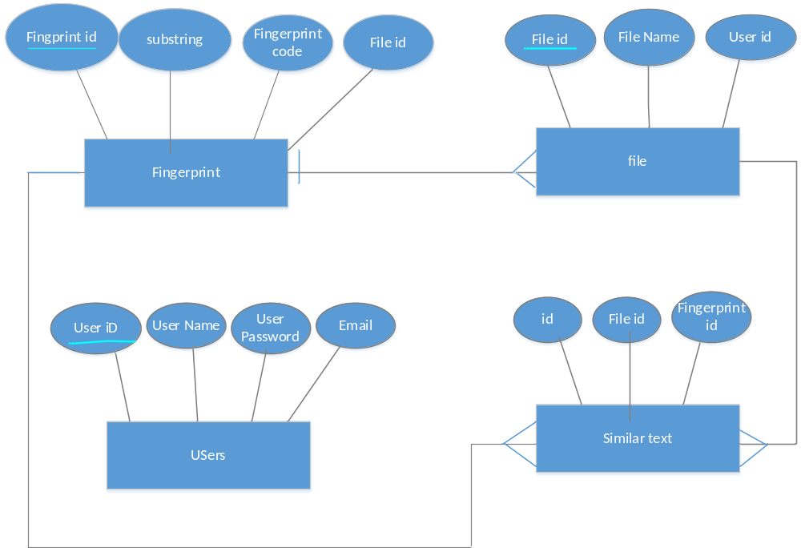

- Sequence Diagrams
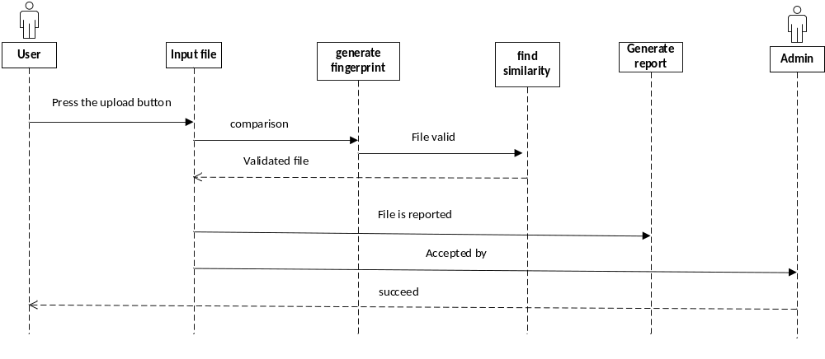
- Architecture Design Diagram

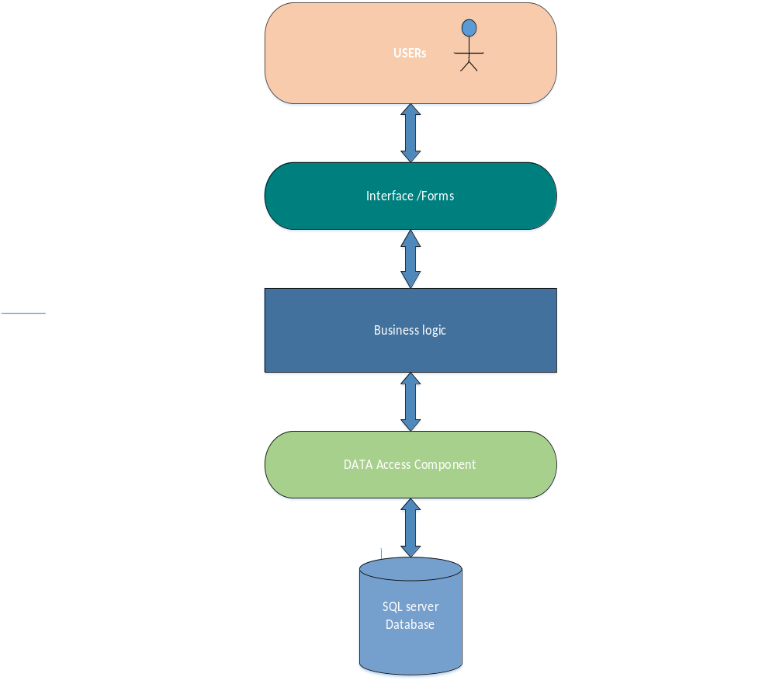
- Class Diagram

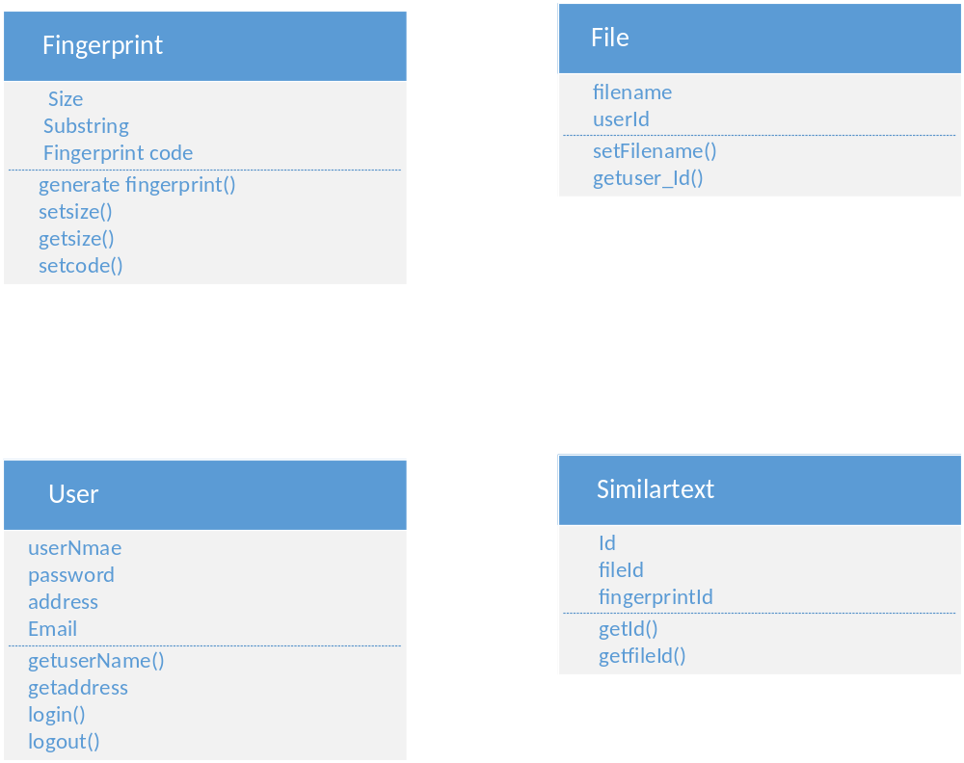

- Database Design

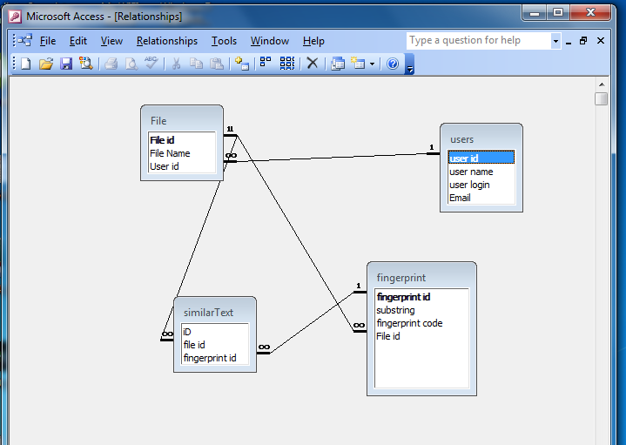

- Interface Design

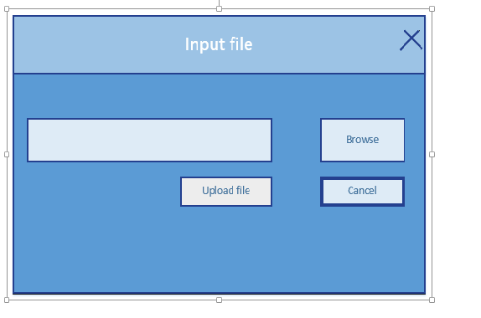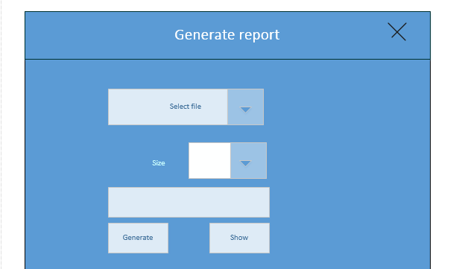

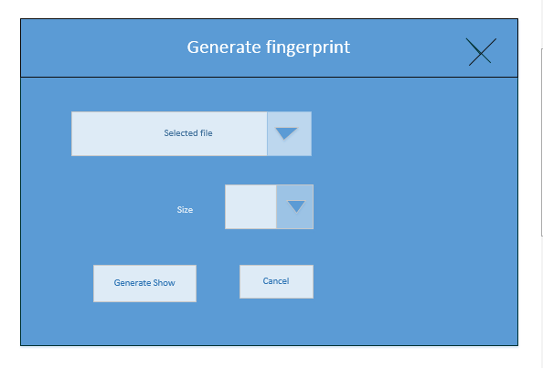
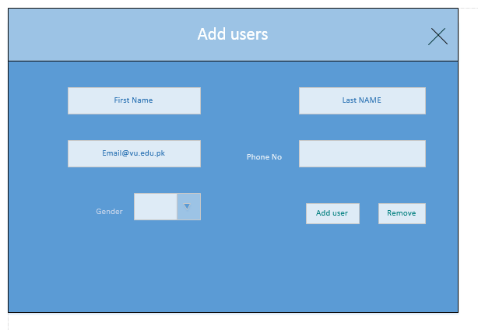

- Test Cases

Test case:1
Test case Id | Te
Test case Name | Input File
Pre condition | The user must be logged in.
Actions | The user must enter valid email and valid password. And then click on Ok.
Expected Results | The user requirements will be complete.
Tested by | Mr. Tanveer Arshad

Test case:2

Test case Id | Test case #2
Test case Name | Input file
Pre condition | Files must be available.
Actions | The user enter valid email and in valid password. And then click on Ok.
Expected Results | The user requirements will be incomplete.
Tested by | Mr. Tanveer Arshad

Test case:3

Test case Id | Test case #3
Test case Name | Input file
Pre condition | Files must be available.
Actions | The user enter invalid email and in valid password. And then click on Ok.
Expected Results | The user requirements will be incomplete.
Tested by | Mr. Tanveer Arshad

Test case:4

Test case Id | Test case #4
Test case Name | Generate fingerprints
Pre condition | Files must be available.
Actions | The system will compare fingerprint of this file with existing fingerprint.  There is similarity in fingerprints.  The system stores these fingerprints and similarity in database.
Expected Results | The files will be succefull.
Tested by | Mr. Tanveer Arshad

Test case:5

Test case Id | Test case #5
Test case Name | Generate fingerprints
Pre condition | Files must be available.
Actions | The system will compare fingerprint of this file with existing fingerprint.  There is not similarity in fingerprints.  The system will not store these fingerprints in database.
Expected Results | The files will be rejected.
Tested by | Mr. Tanveer Arshad

Test case:6

Test case Id | Test case #6
Test case Name | Generate Report
Actions | After successfully comparing the system will generate a browser report. Browser report enable to view compare result.
Expected Results | The system will show success message.
Tested by | Mr. Tanveer Arshad
Test case:7

Test case Id | Test case #7
Test case Name | Generate Report
Actions | Due to invalid files, the system will not generate a browser report.
Expected Results | The system will show error message.
Tested by | Mr. Tanveer Arshad

Test case:8

Test case Id | Test case #8
Test case Name | Add user
Actions | Due to valid requirements, the system will generate a succeful browser report.
Expected Results | The user will be accepted by admin.
Tested by | Mr. Tanveer Arshad

Test case:9

Test case Id | Test case #9
Test case Name | remove user
Actions | Due to invalid requirements and copy the file and paste in other system, the system will show error message.
Expected Results | The user will be rejected by admin.
Tested by | Mr. Tanveer Arshad

